**ASSIST. AFRICA | PRODUCT DEVELOPMENT**

**Virtual Assistant/Freelancer Onboarding Page**

**Onboarding Journey for Experienced VAs**:

**Step 1: Registration**

* User arrives at the registration page and selects the role of "Experienced VA."
* They fill in basic details such as name, email, and password.

**Step 2: Profile Creation**

* User is guided to complete their profile with a profile photo, bio, and contact information.
* They showcase their skills, areas of expertise, and years of experience.
* The user uploads samples of their previous work as part of their portfolio.
* They set their pricing structure for different types of work (hourly, project-based, retainers).

**Step 3: Task Preferences**

* User selects the service categories they specialize in, such as Admin Support, Marketing, or Customer Service.
* They specify their availability for different work arrangements (hourly, project-based, retainers).

**Step 4: Task Bidding**

* User browses tasks posted by clients in their chosen service categories.
* When they find a suitable task, they submit a bid, providing a detailed proposal and estimated cost.
* The platform encourages them to engage in messaging with clients to clarify project details.

**Step 5: Task Completion and Reviews**

* If their bid is accepted, they begin working on the task.
* They maintain communication with the client through the platform's messaging system.
* Upon task completion, they submit deliverables to the client through the platform.
* The client rates and reviews their performance, which contributes to building their reputation.

**Step 6: Earnings and Payments**

* For milestone-based tasks, they wait for client approval of each milestone before payment.
* Payments are released to their account upon milestone approval.

**Step 7: Building Reputation**

* They actively accumulate positive reviews from clients as they complete more tasks.
* User updates their profile, portfolio, and skills to showcase growth and expertise.

**Step 8: Additional Features**

* They use the platform's task management tools to track ongoing projects, deadlines, and communication.
* Notifications alert them about new task postings, messages, and updates.
* The platform offers a comprehensive help center with FAQs, guides, and contact information.
* Users can access resources such as tutorials, webinars, and articles for continuous learning.

**Step 10: Verification & Preferential Treatment**

* Upon reaching a certain level of experience and positive reviews, experienced VAs can apply for verification.
* Verified VAs gain a "Verified" badge on their profiles, indicating their expertise and trustworthiness.
* Verified VAs receive preferential treatment, such as increased visibility in search results and task listings.

**Onboarding Journey for Learning VAs:**

**Step 1: Registration**

* User arrives at the registration page and selects the role of "Learning VA."
* They fill in basic details such as name, email, and password.

**Step 2: Profile Creation**

* User is guided to complete their profile with a profile photo, bio, and contact information.
* They emphasize their interests and enthusiasm for learning in their bio.
* They can mention personal projects or relevant coursework.

**Step 3: Task Preferences**

* User selects the service categories they are interested in learning more about, such as Admin Support, Marketing, or Customer Service.
* They specify their availability for different work arrangements (hourly, project-based, retainers).

**Step 4: Task Bidding**

* User browses tasks posted by clients in their chosen service categories.
* When they find a suitable task, they submit a bid emphasizing their willingness to learn and commitment.
* The platform encourages them to engage in messaging with clients to clarify project details.

**Step 5: Task Completion and Reviews**

* If their bid is accepted, they begin working on the task with a focus on learning.
* They maintain communication with the client through the platform's messaging system.
* Upon task completion, they submit deliverables to the client through the platform.
* The client rates and reviews their performance, contributing to their growth.

**Step 6: Earnings and Payments**

* For milestone-based tasks, they wait for client approval of each milestone before payment.
* Payments are released to their account upon milestone approval.

**Additional Features:**

* **Task Management:** VAs use the platform's task management tools to organize projects, deadlines, and communication.
* **Notifications:** Notifications alert VAs about new task postings, messages, and updates.
* **Help Center:** VAs access a comprehensive help center for platform-related queries.
* **Feedback:** They provide feedback to improve the platform's user experience.
* **Continuous Learning**:
  + Training Resources: The platform offers training resources, guides, and articles for VAs to enhance their skills.
  + Learning Opportunities: VAs can participate in webinars, workshops, or community discussions to foster continuous learning.

**Onboarding Journey for Agency VAs:**

**Step 1: Registration**

* Agencies select the role of "Agency VA."
* They fill in basic details such as the agency name, email, and password.

**Step 2: Agency Profile Creation**

* Agencies complete their profiles with a company logo, a brief description of services offered, and contact information.
* They showcase their collective skills, areas of expertise, and years of experience as an agency.
* The agency can upload samples of their work as a team.

**Step 3: Task Preferences**

* Agencies select the service categories they offer as an agency, such as Admin Support, Marketing, or Customer Service.
* They specify their availability as a team for different work arrangements (hourly, project-based, retainers).

**Step 4: Agency Task Bidding**

* When agencies find suitable tasks, they submit bids on behalf of their VAs, emphasizing the expertise of their team.
* The platform encourages them to engage in messaging with clients to clarify project details.

**Step 5: Task Completion and Reviews**

* As VAs from the agency complete tasks, the agency's overall performance is reviewed and rated by clients.
* Agencies can track the performance of their VAs and provide guidance for improvement.

**Step 6: Agency Earnings and Payments**

* Earnings are allocated to the agency's account, and they manage distribution among their VAs.
* The platform provides clear financial reporting for agencies.
* Agencies can set up preferred payment methods.

**Onboarding Journey for Assist Africa Account Managers (Internal Administrative Function):**

**Step 1: Administrative Assignment**

* Assist Africa administrators or platform managers identify and select individuals who will serve as Account Managers.
* These individuals are typically experienced professionals with a deep understanding of the platform and its operations.

**Step 2: Role Confirmation**

* Selected individuals are formally assigned the role of "Account Manager" by platform administrators.
* They are provided with administrative access to the platform.

**Step 3: Account Manager Training**

* Account Managers receive comprehensive training on their responsibilities and the platform's task management tools.
* Training covers client and VA interaction, project oversight, and dispute resolution, among other topics.

**Step 4: Task Assignment**

* Platform administrators or higher-level staff assign specific tasks or projects to Account Managers based on their expertise and availability.
* Account Managers review project details and client expectations before accepting assignments.

**Step 5: Task Management**

* Account Managers oversee the progress of assigned tasks, ensuring they meet quality standards and deadlines.
* They maintain open communication with clients and VAs involved in the project.
* Account Managers use platform tools to monitor task status and milestones.

**Step 6: Account Manager Compensation**

* Compensation for Account Managers is determined based on their level of involvement and the complexity of the tasks they manage.
* Payment is processed and transferred internally, following platform accounting procedures.

<< **GUIDE FOR PLATFORM DEVELOPERS: CLIENTS' AWARENESS OF ACCOUNT MANAGERS>>**

**1. Introduction During Onboarding:**

* **Objective:** During the client onboarding process, introduce clients to the concept of Account Managers and their role in the platform.
* **Implementation:** Incorporate a section in the client onboarding flow that briefly explains Account Managers. Highlight their function in ensuring a successful collaboration between clients and virtual assistants.

**2. Account Manager Profiles:**

* **Objective:** Create dedicated profiles for Account Managers to provide clients with insights into their qualifications and expertise.
* **Implementation:** Develop Account Manager profiles with the following components:
  + Professional Photo
  + Bio (including qualifications, expertise, and specialization)
  + Contact Information (platform-mediated for security)

**3. Option for Client-Requested Involvement:**

* **Objective:** Allow clients to request the involvement of an Account Manager when posting tasks.
* **Implementation:** Include a feature in the task posting process that enables clients to opt for Account Manager assistance. This could be a checkbox or a dropdown selection.

**4. Task Assignment Notifications:**

* **Objective:** Ensure that both clients and assigned Account Managers are promptly notified when an Account Manager is assigned to a project.
* **Implementation:** Implement a notification system that informs the client that an Account Manager has been assigned to their project. Simultaneously, notify the assigned Account Manager about the project and its details.

**5. Clear Communication Channels:**

* **Objective:** Provide clients with straightforward communication channels to connect with their assigned Account Manager.
* **Implementation:** Create a dedicated messaging system, email integration, or a chat interface that allows clients to interact seamlessly with their Account Manager.

**6. Account Manager Contact Information:**

* **Objective:** Ensure clients can easily access contact information for their Account Manager.
* **Implementation:** Include a section within the platform where clients can find contact details for their assigned Account Manager. This should encompass email addresses, preferred phone numbers, and office hours.

**7. Introduction Message:**

* **Objective:** Encourage Account Managers to initiate contact with clients by sending introductory messages.
* **Implementation:** Develop a feature that prompts Account Managers to send an initial message to clients when they are assigned to a project. This message should briefly introduce the Account Manager, clarify their role, and offer assistance.

**8. In-App Help Center:**

* **Objective:** Create a comprehensive in-app help center that clients can access for information regarding Account Managers.
* **Implementation:** Develop an easily navigable help center that provides insights into the role of Account Managers, instructions on requesting their involvement, and details on how Account Managers can support clients during projects.

**9. Feedback and Ratings:**

* **Objective:** Allow clients to provide feedback and ratings for Account Managers.
* **Implementation:** Develop a rating and feedback system that enables clients to assess the performance of Account Managers. This data can be used for continuous improvement and accountability.

**10. Regular Updates:**

* **Objective:** Facilitate regular communication between Account Managers and clients throughout the project.
* **Implementation:** Enable Account Managers to provide clients with regular updates on project progress, answer queries, and address concerns within the platform's messaging system.

**11. Client Success Stories:**

* **Objective:** Showcase client success stories and testimonials related to positive experiences with Account Managers.
* **Implementation:** Develop a section on the platform, such as the homepage or a dedicated area, where success stories and testimonials can be displayed to highlight the value of Account Managers.

**[Check if these can be implemented now or later on and advise. ]**

**ACCOUNT MANAGERS INVOLVEMENT CRITERIA.**

**1. Task Complexity and Value-Based Assignment:**

* **Objective:** Automatically assign Account Managers to tasks or projects based on their complexity and value.
* **Implementation:**
  + Develop a scoring system that assesses the complexity and value of each task or project. Consider factors like project duration, budget, and task category.
  + Create an algorithm that calculates a complexity and value score for each task.
  + Set predefined thresholds for the complexity and value scores that trigger Account Manager assignment.
  + Implement a task assignment module that checks these scores and assigns Account Managers accordingly.

**2. Client-Requested Assignment:**

* **Objective:** Allow clients to request the involvement of an Account Manager during the task posting process.
* **Implementation:**
  + Include an option in the task posting interface that enables clients to select whether they want an Account Manager.
  + Develop a user-friendly interface that explains the role of Account Managers and the benefits of their involvement.
  + Ensure that the client's request for an Account Manager is recorded and considered during the task assignment process.

**3. Performance History-Based Assignment:**

* **Objective:** Automatically assign Account Managers to tasks involving clients or VAs with a history of issues or disputes.
* **Implementation:**
  + Maintain a performance history database that tracks past issues, disputes, and client or VA behavior.
  + Develop an algorithm that evaluates the historical performance of clients and VAs involved in a task.
  + Set predefined criteria for performance issues that trigger Account Manager assignment.
  + Implement real-time checks during task assignment to assess historical performance and assign Account Managers accordingly.

**4. Task Duration and Budget-Based Assignment:**

* **Objective:** Automatically assign Account Managers to longer-term and higher-budget tasks.
* **Implementation:**
  + Define minimum thresholds for task duration and budget that trigger Account Manager assignment.
  + Create a module that calculates task duration and budget during the task posting process.
  + Integrate these calculations into the task assignment process to assess eligibility for Account Manager involvement.

**5. Task Category-Based Assignment:**

* **Objective:** Automatically assign Account Managers to tasks in specific categories that inherently require more oversight.
* **Implementation:**
  + Categorize tasks into predefined categories, including those that require special attention.
  + Develop a mapping system that associates task categories with potential Account Manager involvement.
  + Assign Account Managers based on the task category chosen by the client.

**6. Client Feedback and Request Assignment:**

* **Objective:** Allow clients to request the involvement of an Account Manager based on their previous positive experiences.
* **Implementation:**
  + Implement a feature that allows clients to select Account Managers they've worked with before.
  + Encourage clients to provide feedback and reviews for Account Managers they've collaborated with.
  + Use positive client feedback and previous requests as indicators for future Account Manager assignments.

**7. Learning VA Involvement:**

* **Objective:** Assign Account Managers to tasks that involve a mix of experienced and learning VAs.
* **Implementation:**
  + Develop an algorithm that checks the experience levels of VAs assigned to a project.
  + Assign an Account Manager when a task involves a combination of experienced and learning VAs.

**8. Legal or Compliance Requirements:**

* **Objective:** Automatically assign Account Managers to tasks with legal or compliance considerations.
* **Implementation:**
  + Identify tasks that involve legal or compliance aspects during task posting.
  + Implement a module that identifies these tasks and assigns an Account Manager.

**9. Continuous Review and Adaptation:**

* **Objective:** Regularly update and adapt the criteria for Account Manager assignment based on feedback and performance.
* **Implementation:**
  + Create a system for periodic reviews of the criteria.
  + Develop an administrative interface that allows platform administrators to adjust the criteria.

**10. Analytics and Data-Driven Decisions:**

* **Objective:** Use data analytics to identify trends and patterns that inform the criteria for Account Manager assignment.
* **Implementation:**
  + Implement data collection and analysis tools to gather information on task success and failure.
  + Use data-driven insights to refine the criteria and improve Account Manager assignment accuracy.

**>>>>>**

**Clients/Businesses Onboarding Page**

**PATHWAY 1: SELECT A SERVICE:**

***Step 1: Service Selection:***

Dropdown Menu:

* Display a dropdown menu with predefined PR services (arranged alphabetically.
* Prompt users to select the service that aligns with their needs.

***Step 2: Task Details:***

Task Description:

* Provide input fields for users to describe their task or project.
* Include fields for details such as project description, target audience, and communication preferences.

***Step 3: Budget and Timeline:***

Budget Range:

* Input field for users to enter their budget range for the selected service.
* Provide context/range of budgets (e.g. 5,000 – 15,000; 15,500 – 35,000; 35,500 – 55,000; 55,500 – 75,000; Above 75,000.

Timeline:

* Input field for users to specify their preferred timeline or deadline for the task.

***Step 4: Review and Confirmation:***

Summary:

* Display a summary of the selected service, task details, budget range, and timeline.
* Allow users to review/edit the information they provided.

Confirm:

* Provide a "Confirm" or "Submit" button for users to proceed.
* Optionally, include a "Go Back" button for users to make changes.

**PATHWAY 2: GET GUIDANCE:**

***Step 1: Guidance Option:***

Options Display:

* Present two options: "Fill in Details" or "Book a Call."
* Users can choose the option that best suits their preferences.

***Step 2: Fill in Details:***

Input Fields:

* Display input fields for users to provide their name, email, business name, and a brief description of their PR goals.
* Include fields for budget range and any other relevant details.

***Step 3: Submit Details:***

Review:

* Allow users to review the information they entered.
* Provide an option to edit or make changes if necessary.

Submit:

* Include a "Submit" or "Get Guidance" button to proceed.

***Step 4: Book a Call:***

Calendar Widget:

* Display a calendar widget with available time slots for consultation calls.
* Users can select a time slot that suits their schedule.

***Step 5: Confirmation:***

Confirmation Message:

* Display a confirmation message indicating that the request for guidance has been received.
* If applicable, provide details about the booked consultation call.

***Final Steps:***

* After users confirm their selections in either pathway, direct them to the relevant section of the platform based on their choices.
* Provide clear navigation options to guide users further, such as "Browse Tasks," "Dashboard," or other relevant sections.

**ONBOARDING PROCESS**

**Client Onboarding**

**Step 1 Step 2**

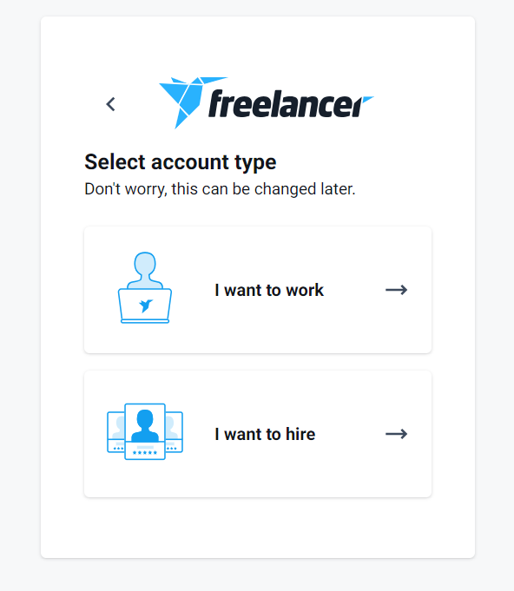

**Step 3.1**

**Step 3.1.1**

**Step 3.1.2**

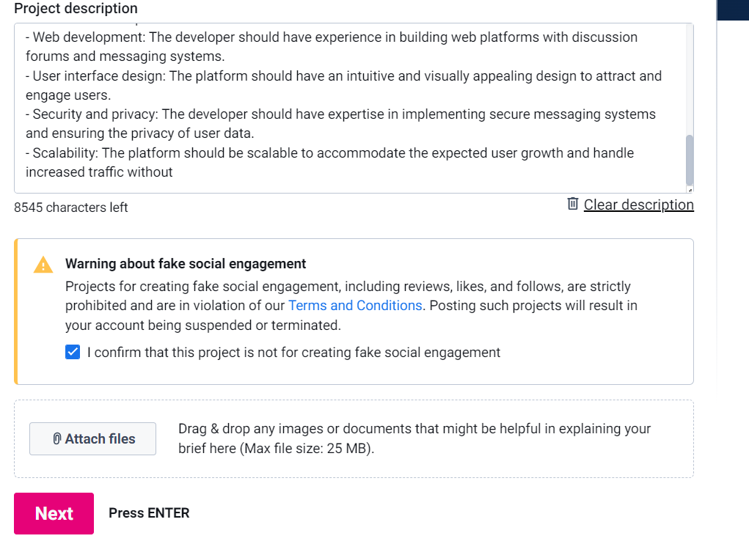

**Highlight (3.1.2)**

**Step 3.1.3**

**Step 3.1.4**

**Step 3.1.4.1**

**Step 3.1.4.2**

**Step 3.1.4.3**

